#### Introduction

A classifier in Data Science is a machine learning model/algorithm that we use to differentiate between various objects based on the certain features of that object. For example, an image classifier would classify images into different objects like “image of animal”, “image of vehicle”, “image of cats”, etc. Here, we can objectify various classes for classifiers like: animal, vehicle, cat, etc.

Classifier implements a set of mathematical reasoning to generate a model for prediction on data points. Assigning data input to a certain class label is one of the fundamental functions of many AI applications, and most of the algorithms running in clusters that deal with huge amounts of data consist of various sets of classifiers to get the desired output. Therefore, it becomes important to grasp the fundamentals of classifiers and know how they work. In this blog, we’ll discuss the Naive Bayes Classifier.

A Naive Bayes classifier is a machine learning model that is based on the theory of probability and used for mainly classification tasks. NBC has been mostly used in machine learning for text analysis and classifications problems. In this blog, we will be designing and training a classifier model using Naive Bayes classifier.

____

Histogram and conditional probability

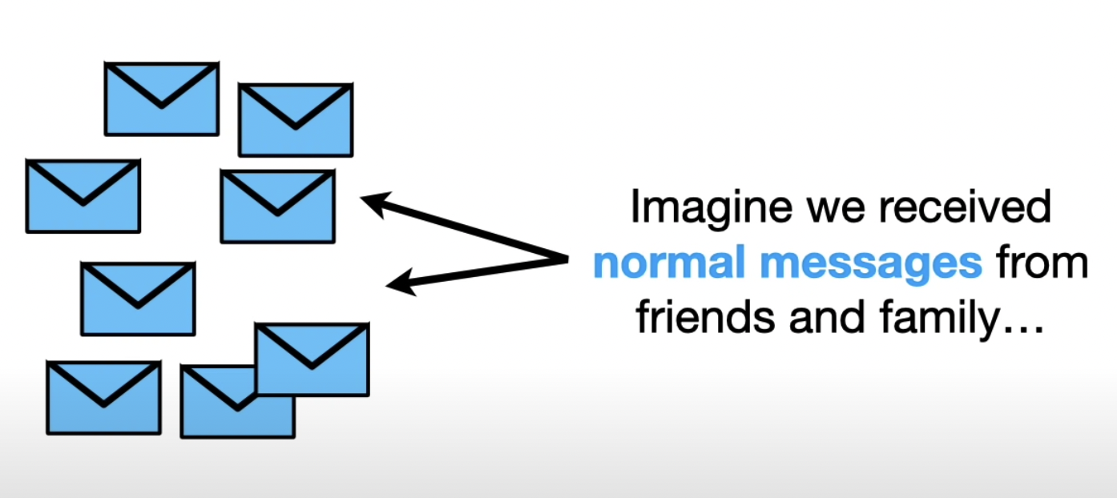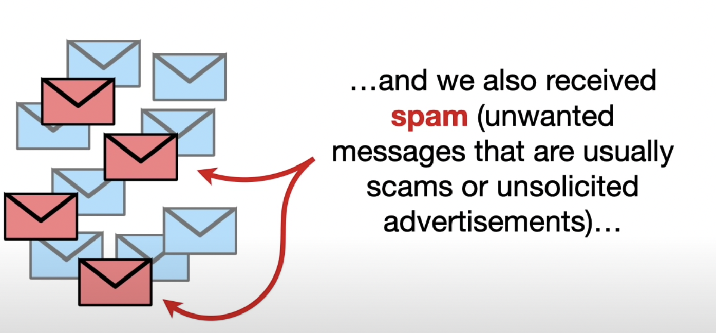

Lets assume we received a normal text messages work, friends and family and at the same time, we also receive spam message that are basically unwanted messages that are usually scams or unsolicited advertisements.

Here we want to filter out the spam messages from our inbox

First thing we want to do is make a histogram of all the words that occurs in our normal, legitimate messages that we get from friends and family. We can use the histogram to calculate the probabilities of seeing each words in messages assuming it was a normal message.

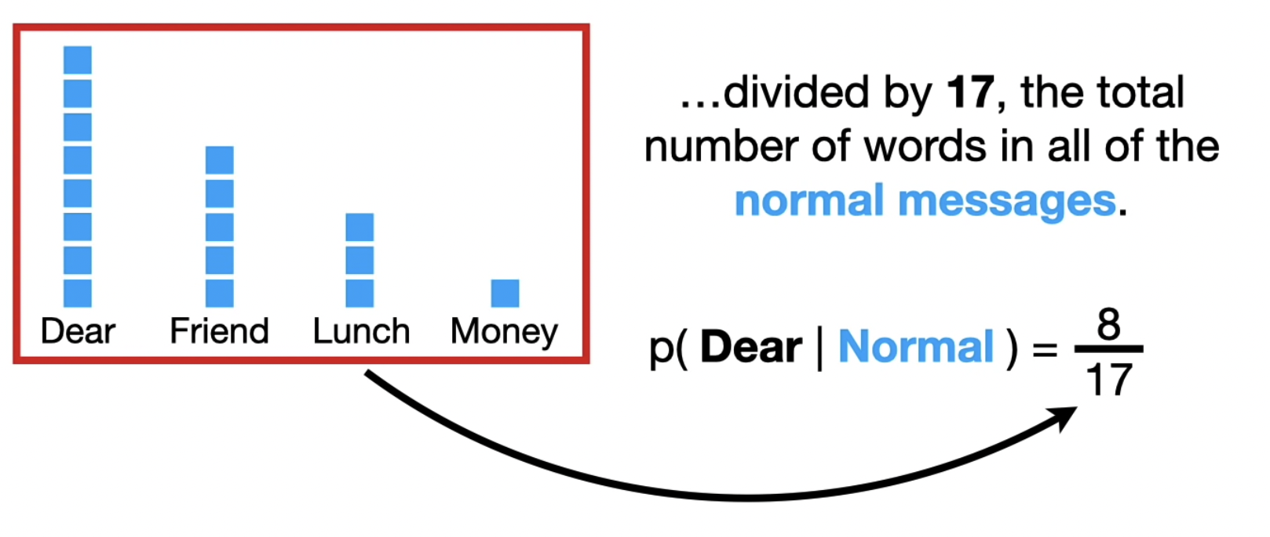

Given above is a histogram of words in the normal messages. Here, the word ‘Dear’ was occurred 8 times in normal messages out of all the words in normal messages i.e. 17

And that gives us the probability of 0.47

Similarly, we calculate the probability of each words occurring in original messages given the total number of unique words in messages and we create a histogram of it.

Here’re we can see the probability of each unique words in the original messages. \

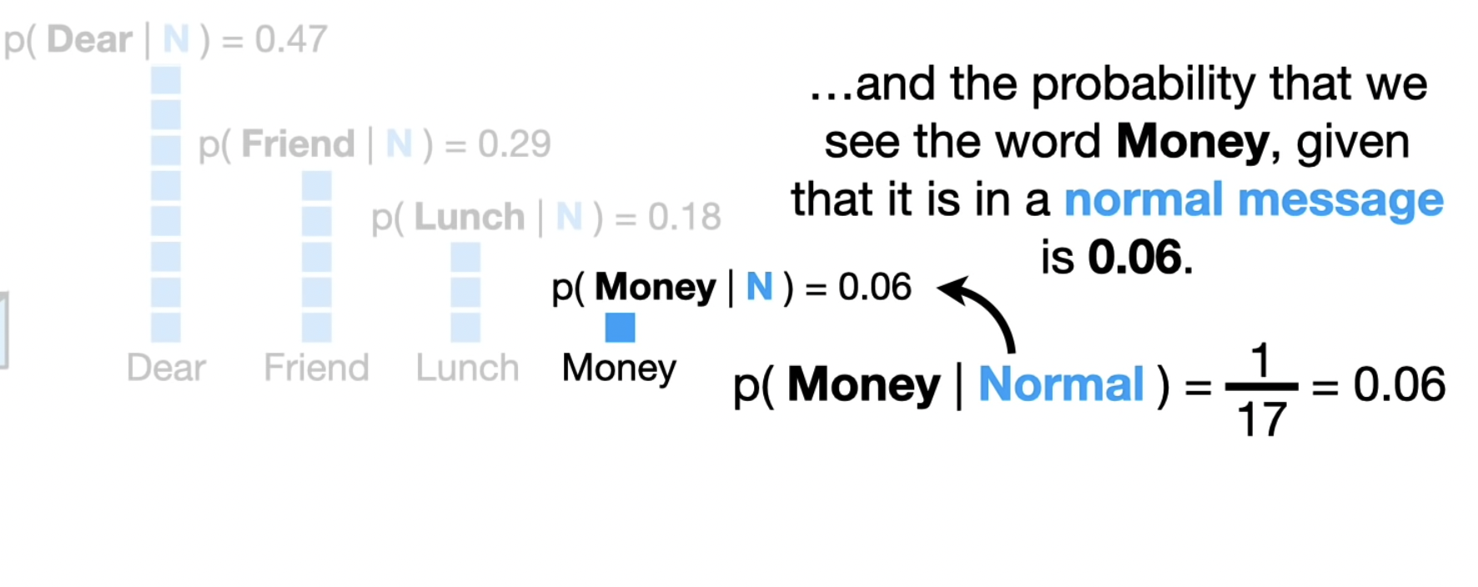

Similarly, we do the same operations on the spam messages and calculate the probability of each unique words in the spam messages